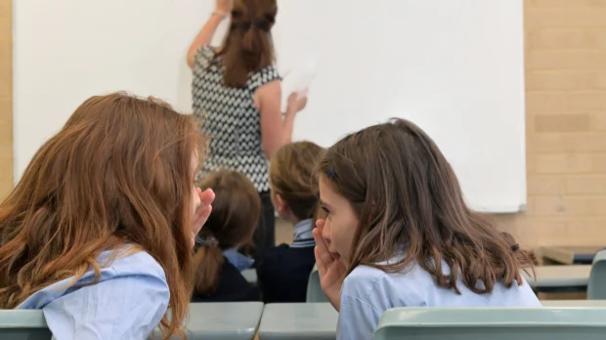

The elephant in the classroom: Why student engagement is the reform we keep avoiding

Dr Paul Browning OAM

Something doesn't quite add up, and the longer you spend in education, the harder it is to ignore.
As a long-term educator and former school principal, I know first-hand that our current approach to schooling really isn't working as well as we'd like to believe. You would have to be wilfully looking away to claim we're doing a great job, generally speaking. Students have increasingly shown up to class in body but not in mind, going through the motions without any real investment in what's happening in front of them.
A conversation with a couple of Year 9 girls a few weeks before the start of this year confirmed everything the research has been telling us about student disengagement for years.
"Our classes are boring."
"Why?"
"Well, the teacher asks us to open the textbook at page whatever and then reads to us. We can read, you know. We could just do that at home."
Hard to argue with that.

What the data tells us
These girls aren't outliers. They're the norm. Research from Monash University found that in South Australian secondary schools, just 60% of students reported finding school engaging, while more than two-thirds of teachers said they observed disengaged behaviours on an almost daily basis. A Grattan Institute report found that approximately 40% of Australian school students are regularly unproductive, bored, and struggling to keep up with their peers, what researchers called the "hidden issue" of passive disengagement. And the consequences are serious: around 25% of disengaged young people do not complete school at all.
Meanwhile, academic results paint a similarly troubling picture. According to PISA (the Programme for International Student Assessment), Australian 15-year-olds' mathematics scores fell from 524 points in 2000 to 487 in 2022, roughly equivalent to 16 months of lost learning. Reading scores dropped from 528 to 498 over the same period. And NAPLAN data shows that one in three Australian students is currently not meeting basic expectations in literacy and numeracy, despite record levels of government investment in education.
So we are spending more, and getting less. Something isn't adding up.

The reform we reached for
Almost in desperation to arrest the slide in results, there has been a significant push toward direct and explicit instruction, an evidence-based approach that has strong research support for improving outcomes when applied well. I'm not dismissing that. Direct and explicit instruction has genuine merit, and the evidence is real.
But here is the question I keep coming back to: has anyone systematically examined the relationship between how we teach and whether students are actually engaged with their learning? And I'm separating those two words deliberately--teaching, and, learning--because they are not the same thing. You can teach without learning occurring (although, sometimes what the student actually learns is how to teach themselves).
I'll leave that question hanging for a moment.

The recipient's experience
Here is what troubles me most. As teachers and school leaders, we observe disengagement every single day. We talk about it in staff rooms. We read reports about it. The logical hypothesis seems almost too obvious to state: could there be a correlation between boring lessons and declining outcomes? Could highly engaged students, who have genuine agency over their learning, simply achieve better results?
When we look to improve education, we turn to "the research", but we rarely stop to consult the very people on the receiving end of our teaching. Surely the clearest signal about what's working and what isn't comes from the students themselves?
I had a conversation recently with the father of a Year 10 student who had just changed schools because the teaching at her previous school was so uninspiring that she instinctively knew she wasn't reaching her potential. She was, in her own words, just cruising. Last year she taught herself English using AI at home and received an A. She didn't give the teacher any credit for that result.
But here's the other side of that story. In Year 9, this same young woman developed a deep passion for history. Part of her reason for changing schools was that history was offered as an elective in Year 10 at her old school and she had missed out on a spot.
Where did that passion come from? Her teacher.
In Year 9 she encountered passionate teaching that brought a subject to life, one that most students dismiss as dull and disconnected from their lives. Did that teacher use direct and explicit instruction? Possibly. Probably. But no doubt they also drew on a whole range of other pedagogical approaches to ignite genuine enthusiasm and deep learning.

The question we're not asking
That's the paradox sitting at the heart of Australian education (and probably all western countries) right now. We are chasing improved test scores, understandably so, but we are having the wrong conversation. We are debating instructional methods while the student in front of us has mentally checked out.
Research consistently shows that when Australian students feel their teachers use supportive, encouragement-based practices, and when they are given opportunities for self-initiative in their learning, they report significantly lower disengagement. The relationship between teacher practice, student experience, and academic outcomes is not incidental. It is central.
So let's be honest with ourselves. Let's stop making teaching boring, and instead ask, really ask, how we can make learning genuinely engaging? The answer to improving education might be less complicated than we think. It might just require us to start listening to the students sitting in front of us and start changing the way we teach.
They've been trying to tell us for years. When will we have the courage to listen and change how we teach?

And can I end by being provocative?

Let's stop blaming the curriculum, or making the excuse that there is too much content to get through.
There is a better way.

